**Online Class Talk**

**BY**

**Syeda Tasfia Hossain**

**ID: 171-15-8581**

**Alkuma Akther**

**ID: 171-15-8582**

**AND**

**Sakib Uddin Ahmed**

**ID: 171-15-8782**

This Report Presented in Partial Fulfillment of the Requirements for the Degree of Bachelor of Science in Computer Science and Engineering.

Supervised By

**Mr. Narayan Ranjan Chakraborty**

Assistant Professor

Department of CSE

Daffodil International University

Co-Supervised By

**Md. Tarek Habib**

Assistant Professor

Department of CSE

Daffodil International University



**DAFFODIL INTERNATIONAL UNIVERSITY**

**DHAKA, BANGLADESH**

**JANUARY 2020**

**APPROVAL**

This Project titled **“Online Class Talk”**, submitted by Sakib Uddin Ahmed**,** Alkuma Akther and Syeda Tasfia Hossain to the Department of Computer Science and Engineering, Daffodil International University, has been accepted as satisfactory for the partial fulfillment of the requirements for the degree of B.Sc. in Computer Science and Engineering and approved as to its style and contents.

**BOARD OF EXAMINERS**

**(Name)** [**Font-12, Bold**] **Chairman**

**Designation**

Department of CSE [**Font-12**]

Faculty of Science & Information Technology

Daffodil International University

**(Name) Internal Examiner**

**Designation**

Department of CSE

Faculty of Science & Information Technology

Daffodil International University

**(Name) External Examiner**

**Designation**

Department of -------

Jahangirnagar University

**DECLARATION**

We hereby declare that; this project has been done by us under the supervision of **Mr. Narayan Ranjan Chakraborty, Assistant professor, Department of CSE**Daffodil International University. We also declare that neither this project nor any part of this project has been submitted elsewhere for the award of any degree or diploma.

**Supervised by:**

**Mr. Narayan Ranjan Chakraborty**

Assistant Professor

Department of CSE

Daffodil International University

**Co-Supervised by:**

**Md. Tarek Habib**

Assistant Professor

Department of CSE

Daffodil International University

**Submitted by:**

**Sakib Uddin Ahmed**

ID: 171-15-8782

Department of CSE

Daffodil International University

**Alkuma Akther Munna**

ID: 171-15-8582

Department of CSE

Daffodil International University

**Syeda Tasfia Hossain**

ID: 171-15-8581

Department of CSE

Daffodil International University

**ACKNOWLEDGEMENT**

First, we express our heartiest thanks and gratefulness to almighty ALLAH for his divine blessing makes us possible to complete our final year project successful. But there are others, without their support, encouragement and appreciation we would not be able to bring our project into light of success. We, from the core of our heart, want to thank them all.

We want to thank our honorable **Supervisor Mr. Narayan Ranjan Chakraborty, Assistant Professor,** Department of Computer Science & Engineering, Daffodil International University**.** Deep knowledge and keen interest of our supervisor in the field of “Database management system” to carry out this project. His endless patience, encouragement, expert advice and above all his friendly behavior towards us have made it possible to complete this project.

We would like to express our heartiest gratitude to **Dr. Syed Akhter Hossain, Professor and Head**, Department of CSE, for his kind help to finish our project and also to other faculty member and the staff of CSE department of Daffodil International University.

Next, we must thank and acknowledge our university, Daffodil International University. We also want to thank our beloved classmates and other students of the university who took part in research purpose for our project and appreciated our work.

Lastly, we want to thank our beloved families, who were always by our side and kept faith on us. Without our family support, we could never be here, we cordially thank them for this. We also thank our friends for their support and help to us.

**ABSTRACT**

In this project, we have built up a web-based with different types of necessary features and unique features. The purpose of our project “ONLINE CLASS TALK” is easier to communicate with students and teachers. It saves students time and expenses. Students can virtually contact their teachers. For any kind of confusion at the selected course, they can solve with the help of this system quite easily. It provides an answer to collaborative learning for the students. Our management system is actually for teachers and students. They can view, download lectures provided by teachers. As per the title name Online Class Talk so the purpose of this system is to help the education system. Students and Teachers can create a post, comment. Students don’t need to meet physically with teachers. Our project's special feature is a chatting system. We used JAVASCRIPT, HTML, and CSS to design this website. After finishing our website, we also implemented an Android application to make it more user friendly. In the wake of finishing all tasks, the website and application tested in various stages and was discovered working effectively.

|  |  |  |
| --- | --- | --- |
|  | **TABLE OF CONTENT** |  |
| **CONTENT** | | **PAGE** |
| Board of Examiners | | II |
| Declaration | | III |
| Acknowledgements | | IV |
| Abstract | | V |
| **CHAPTER 1: INTRODUCTION** | | 10-11 |
| 1.1 | Introduction | 10 |
| 1.2 | Motivation | 10 |
| 1.3 | Objectives | 10 |
| 1.4 | Expected Outcome | 11 |
| 1.5 | Report Layout | 11 |
| **CHAPTER 2: BACKGROUND** | | 12-13 |
| 2.1 | Introduction | 12 |
| 2.2 | Related Works | 12 |
| 2.3 | Comparative Studies | 12 |
| 2.4 | Challenges | 12-13 |
| **CHAPTER 3: REQUIREMENT SPECIFICATION** | | 14-24 |
| 3.1 | Business Process Modeling | 14 |
| 3.2 | Requirement Collection and Analysis | 14-17 |
| 3.3 | Use Case Modeling and Description | 18 |
| 3.4  3.5  3.6  3.7 | UML Object Diagram  Data Flow Diagram  Activity Diagram  Entity Relationship Diagram | 19  20-22  23  24 |
| **CHAPTER 4: DESIGN SPECIFICATION** | | **17-22** |
| 4.1 | Home page Introduction design | 17 |
| 4.2  4.2.1  4.2.2  4.2.3 | Implementation Requirements  Resource Requirement  Xampp  Visual Studio Code | 21  21  21  21 |
| **CHAPTER 5: IMPLEMENTING AND TESTING** | | 22-26 |
| 5.1 | Implementation of Database | 22 |
| 5.2 | Implementation of Front-end Design | 23 |
| 5.3 | Implementation of Interactions | 25 |
| 5.4 | Testing Implementation | 26 |
| **CHAPTER 6: CONCLUSION AND FUTURE SCOPE** | | 27 |
| 6.1  6.2 | Discussion and Conclusion  Goal | 27  27 |
| 6.3 | Scope for Further Developments | 27 |
| **REFERENCES** | | 27 |
| **APENDIX** | | 28 |
| Appendix A: Project Reflection | | 28 |
| Appendix B: Related Diagrams | | 28 |

|  |  |  |
| --- | --- | --- |
| **FIGURES** | **LIST OF FIGURES** | **PAGE NO** |
| 01 | Business Process Model | 14 |
| 02 | Use case Modeling and Description | 18 |
| 03 | UML Object Diagram | 19 |
| 04 | Data Flow Diagram | 20 |
| 05 | Activity Diagram | 23 |
| 06 | Entity Relationship Diagram | 24 |

**CHAPTER 1**

**Introduction**

* 1. **Introduction**

This project is a website for the Educational System in Bangladesh. We are trying to make a platform so that users can easily connect to the online class.

This website will help the students to make their online classes easier. Online Class Talk System will also help the teacher and students to let them know about the information of the Desire subject in an online system. There is a new feature which is the chatting system. Users can know about the information of every registered class. It saves students time and expenses. Students can virtually contact their teachers. For any kind of confusion at the selected course, they can solve with the help of this system quite easily. It provides an answer to collaborative learning for the students.

After making the website we will make an android application related to our site so that it can be more user friendly.

There are no such websites or applications till now in Bangladesh.

**Motivation**

For users-

It will reduce the sufferings of Students and teachers. By using our project one can easily get the counseling facility of their teacher. They can fix their meeting and solve their problems by using the chatting system. Students do not need to meet with their teacher physically. It saves their valuable time. Our Web application will be a useful app when any kind of pandemic situation occurred. Using this web application in pandemic situations will not delay the education system.

* 1. **Objective**

Using this system users will be able to know about their Online Class system.

**Services at a glance:**

* Firstly, students need to register for their desire course with a joining code. Which is generated by their course teacher.
* There is an available Login section for each type of user.
* Dashboard with associated functions are available for every user.
* Section of news, administration, FAQ, and information, of those announcements.
* Output an HTML file with a slide frame, video frame, and a table of contents of course material. HTML pages are supported by all popular browsers.
* Maintain course and study material of those courses.
* Students Communication with teachers is easy.
* There is a Chatting option.
* Users can share any kind of documents.
  1. **Expected Outcome**
* At first, students need to register for their required course.
* A user can get all the related information staying at home and they can sit for a meeting if they need.
* Students can easily know about the counseling hour of a teacher through chatting.
* Students can easily connect with their teacher by chatting method.
* All the information will be updated. When any user creates any post then an automatic notification will be generated.
* As the website every information in detail, so it also saves the users time.
  1. **Report Layout**

**The chapter (1):** We have described the introduction of our project, motivation, objective, and expected outcome of the project.

**The chapter (2):** We have described the background of our work. We have included a previous work that is related to our work. Also described the comparative studies and find out the challenges, problems.

**The chapter (3):** We have described the requirements and some models like business process modeling, use case modeling, and Data Flow Diagram, ER Diagram, UML Object Diagram. Also described the required data, designs, and analysis.

**The chapter (4)**: We have described front-end and back-end design in this chapter.

**The chapter (5):** In chapter five we have described the implementation and testing part. It includes test results, reports, etc.

**The chapter (6):** In this chapter, we have discussed the future scope for further development.

**CHAPTER 2**

**Background**

**2.1 Introduction**

Bangladesh is a developing country. This country is developing day by day in every sector. Nowadays everything is becoming internet-based. In this chapter, we discussed background studies on the information. We have discussed a few similar approaches that resemble our attempt. We discussed what could be the possible outcome of our project. We also discussed the challenges of our project.

**2.2 Related Works**

There is a similar type of work called google classroom. But our project has an extra and special feature. We want to modify google classroom as well. We designed and implement our project in our way. We want to make our project more efficient than google classroom. So, it is not fully similar to google classroom.

**2.3 Comparative studies**

Comparing some previous works our project is unique. There is a feature like the Chatting system is different from another project. There are no such websites or applications which can provide all chatting system, counseling hour, group chatting, both teacher and students file uploading system, etc. in one platform.

**2.4 Challenges**

In every step, we face many problems and challenges in our life. To make such a useful web application where we have to store a huge amount of information and compare them with one another was not so easy for us.

To do our project we faced some problems-

▪ The most important challenging task was to compare the information because there were huge data and we had to compare it among all of them.

▪ It was a difficult challenge for us because no matter we have to complete it at a given time. If we were unable to complete it on time, it would be great harm to our educational background. So, we just divided our time to complete each one of the tasks to complete the whole project.

* One big challenge was to generate our database. There are so much data. So, it was hard to organize that dataset.
* Without effective communication among everyone involved in the project is tough for its successful completion.

In the end, we overcame all the challenges by the grace of the Almighty.

**CHAPTER 3**

**Requirement Specification**

* 1. **Business process Model**

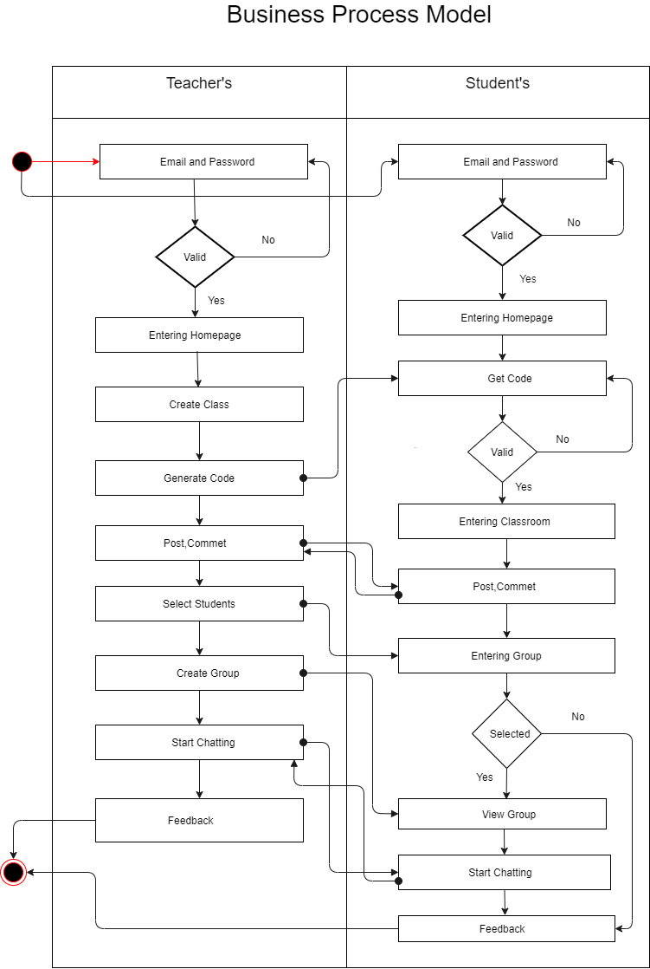

# 3.2 Requirement collection and analysis

Application requirements:

* User
* Continuously update the information
* Time convenience
* User-friendly
* Easily to accessible
* Log in the system for the Admin
* Browser Access
* Get feedback message via user

## 3.2.1Hardware and Software Requirements for Our System

At the very first, you must check the hardware for your computer, you should first make sure that your computer supports the system requirements and ready to operate. These are the necessary specifications that must have in order to use the software and hardware to be used properly, all computer software needs some common hardware components or other software resources to be present on a computer.

In the development area, the system requires for all tools and platforms to perform the new system like

* + - 1. XAMPP (New version will be good)
      2. TEXT editor: Sublime Text Editor
      3. Any browser which supports JavaScript

We have to use some design parts with JavaScript, so If any browser is restricted about java then the design won’t work. That’s why we needed browser which able to run java code.

## 3.2.2 Analysis

After we have seen the problem of the old system we make that understand there is a great need to develop a new system like this. We decided to take HTML and CSS as front end and PHP to backend and MYSQL for DB as a solution.

Strategy for this problem, because PHP is a server-side scripting language for developing a web-based application and that is peaceful to be developed.

**3.3 Use Case Modeling and Description**

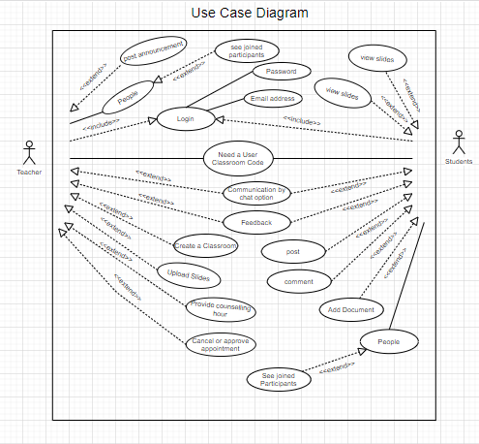

**3.4 UML Object Diagram**

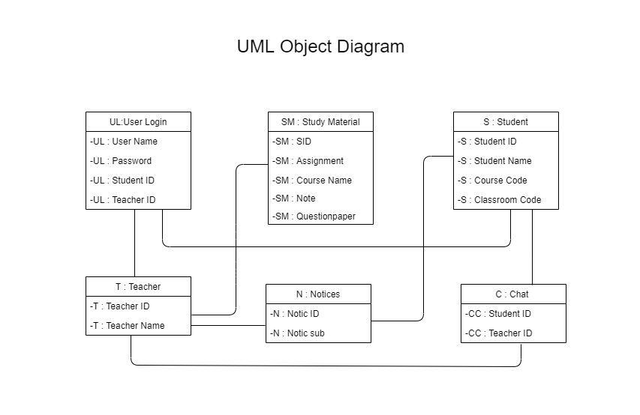

**3.5 Data Flow Diagram**

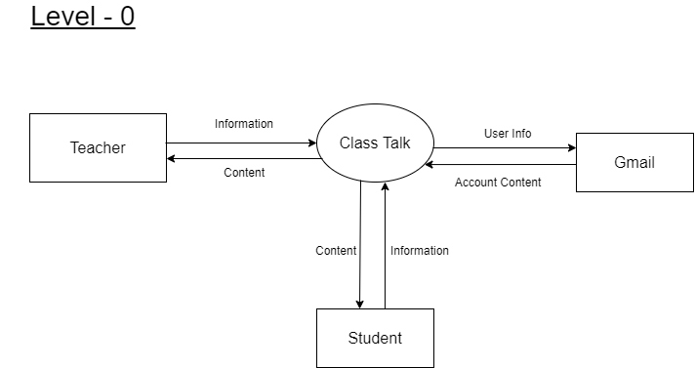

Fig: DFD0

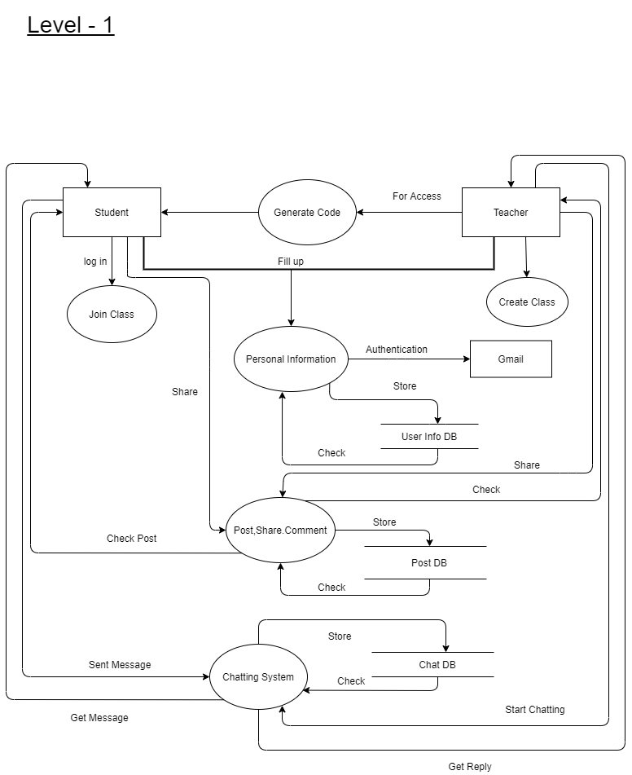

Fig: DFD1

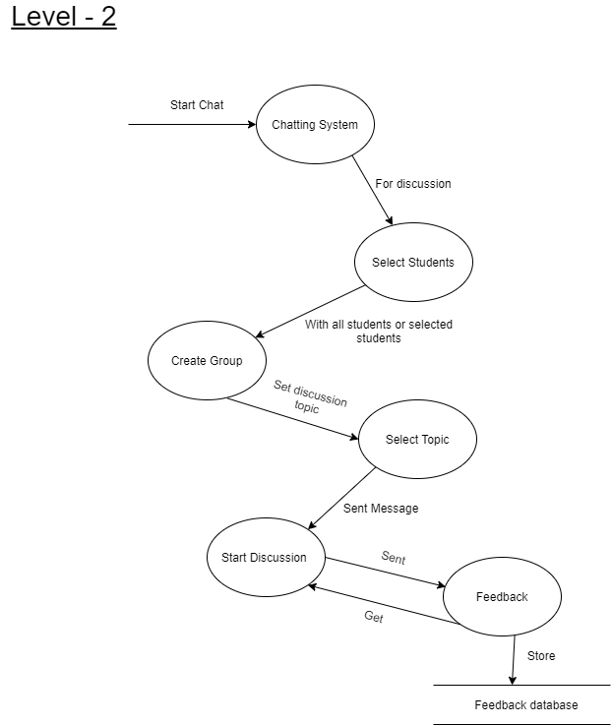

Fig: DFD2

**3.6 Activity Diagram**

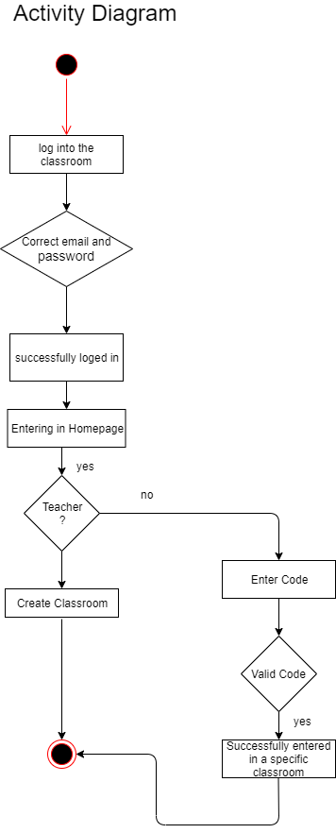

**3.7 Entity Relationship Diagram**

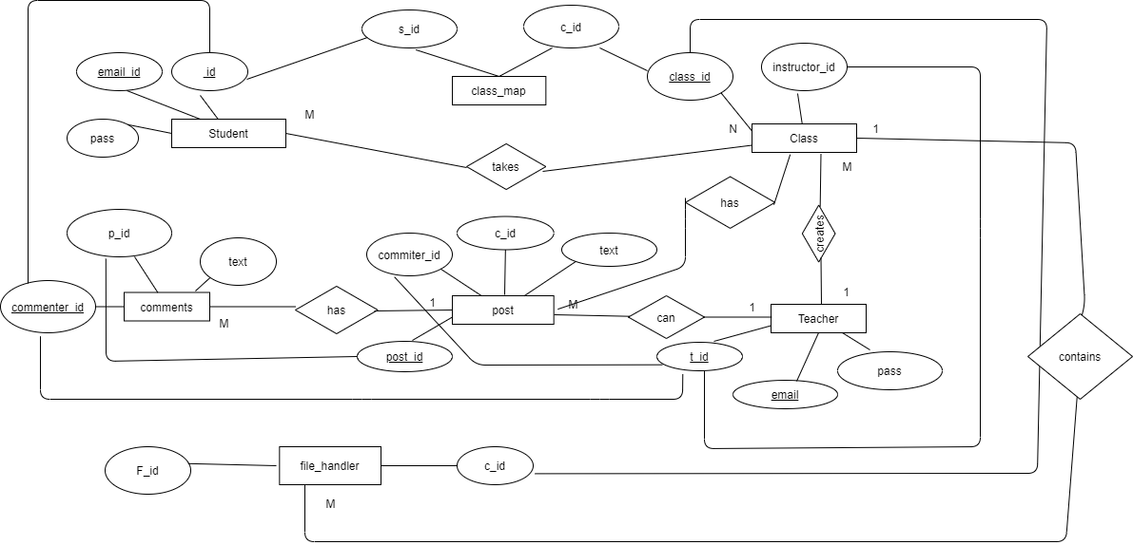

**CHAPTER 4**

## HTML: - Hyper Text Markup Language

HTML is the standard markup language for creating dynamic Web pages. HTML stands for Hyper Text Markup Language and now html5 version running. HTML describes the structure of Web pages using markup. HTML elements are represented by so many different tags. Tags label pieces of content like "heading", "paragraph", "table", and so many others we used. Browsers do not display the HTML tags, only shown the content of the tags.

## Java-Script

[What is JavaScript?](https://javascript.info/intro" \l "what-is-javascript)JavaScript was initially created to “make webpages alive” and attractive.The programs in thislanguage are called scripts languages. They can be written between in the HTML and execute automaticallywhen the pages loads.Scripts are executed as a plain text. They don’t need a special preparation to run.In this aspect, JavaScript is very different and effective from another language called [Java](http://en.wikipedia.org/wiki/Java).

## CSS: - Cascading Style Sheet

CSS (Cascading Style Sheets) is used to style and lay out of a web pages — for example, to change the font, color, shape and spacing of your content, divide it into multiple columns, or add animations for your pages and other features. This module gets you started on the path to CSS mastery with the basics of how it actually works, including selectors and properties of tags, writing CSS rules and regulation, applying CSS to HTML, how to specify a content length, color, and other units in CSS.

## jQuery

jQueryis an open source JavaScript library. Which simplifies the interactions between an HTML/CSS document, and JavaScript. Elaborating the content terms, jQuery extract HTML document traversing and manipulation, also browsers event handling, Ajax interactions, and the cross-browser JavaScript development.

## Bootstrap

As we say Bootstrap is a free and open-source front-end web framework for designing websites and web applications. We used bootstrap framework to build our web application mobile responsive. It also helps us to make our webpage more lucrative and dynamic and user friendly. Bootstrap provides a huge number of functions that control things such as color and padding of various components.

# Back-end Design

## Object Oriented PHP

PHP stands for Hypertext Preprocessor (no, the acronym doesn't follow the name). It's an open source language, server-side, scripting language are also used for the development of web applications. PHP is a widely-used open source general-purpose scripting language that that’s why many resources you can find in google. We use some raw level PHP code for our application.

## MySQL

MySQL works more faster and works well even with large data sets. MySQL is very user-friendly to PHP, the most committed language for web development. MySQL supports large databases, up to fifty (50) million rows or more in a table.

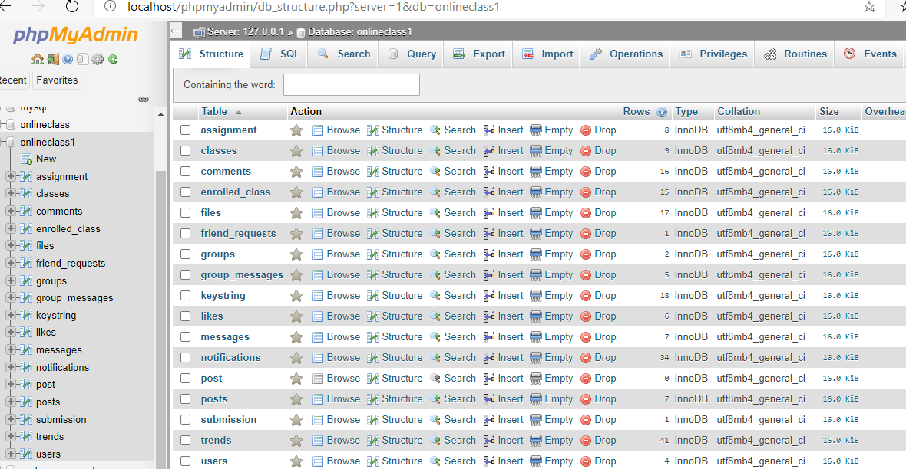

**Fig: Database table list**

**Chapter-5**

**IMPLEMENTATION AND TESTING**

**5.1 Implementation of Database**

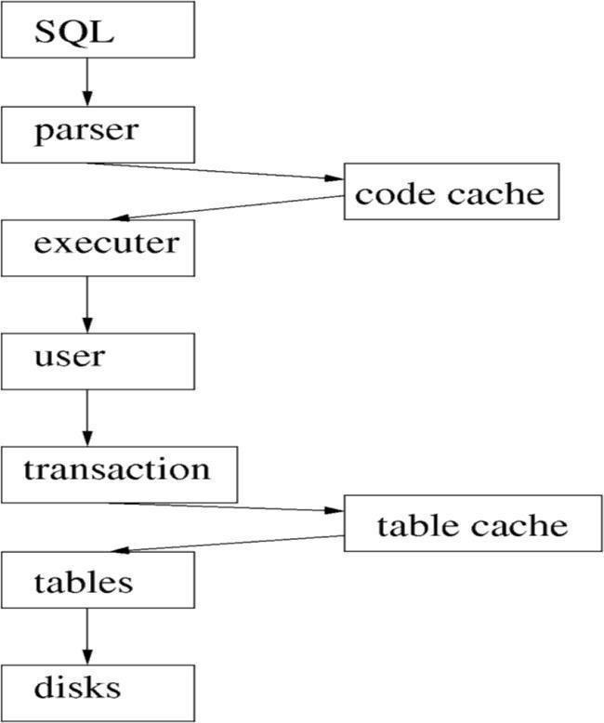We know that the physical implementation of a database is different from the physical model. The physical model refers the database in a specific working environment that includes a distinct database product, a specific hardware and network configuration for the database, and a specific type of data modify and retrieval activity.

Figure 5.1: Database Processing System in Project

Establishment requirements involves consultation, and agreement among the stakeholders about what they want from a system, expressed as a statement of requirements.

The accompanying chart gives us a thought of the approach taken after by two unique frameworks, Oracle and MySQL.

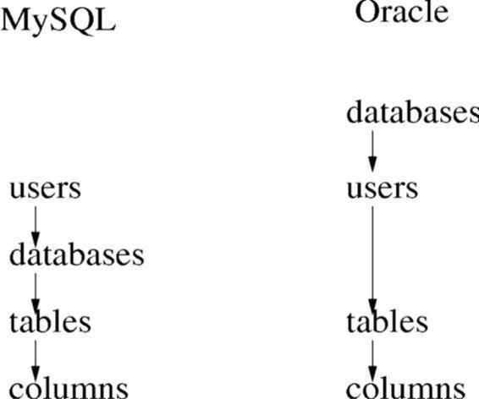

**Figure 5.2:** Users and tablespaces

From this image, we can see that how we have stored the bank and insurances company’s information in each time they updated us.

* 1. **Implementation of Front-end Design**

Many Front-end designs and the description are given here:

After implementing this project Front-end Design, the challenges were many. When we complete the implementation part of the design from the code we write and there the color combination and perfection was the main priority for us. In Front-end implementation we have used different languages such as HTML, CSS, Bootstrap, AJAX and JavaScript to code the website. The code we write runs inside the user’s appropriate browser.

* + 1. **Homepage**

The homepage of this project contain login which only done by google OATH Client. The other All of those are remain in our home page.

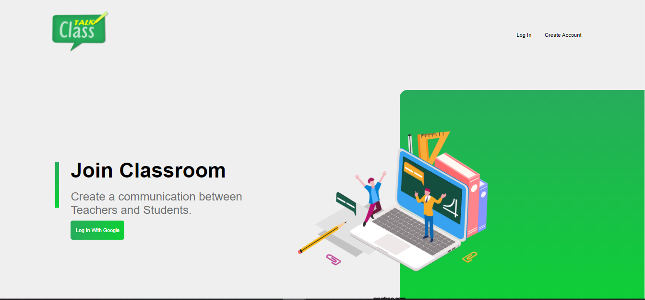

**Figure 5.3:** Homepage Design

* + 1. **Login With Google**

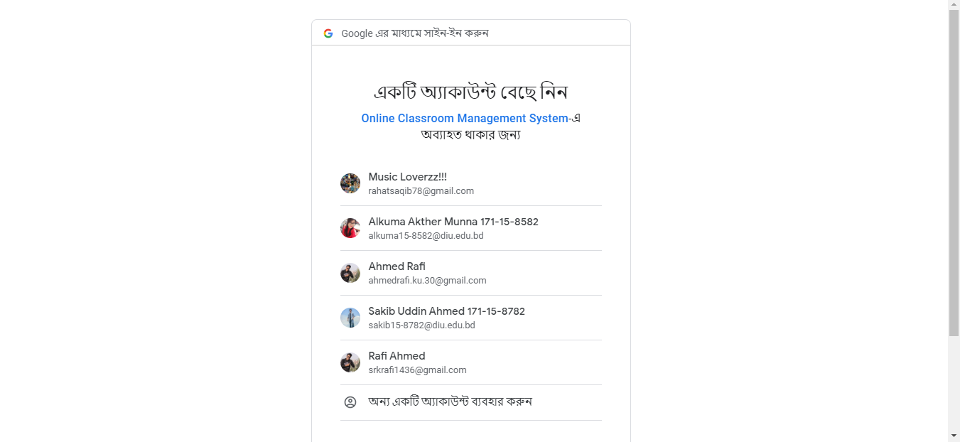

* + 1. **Join Class**

After join classtalk we can join or add any classes for students. This the main page of joining class.

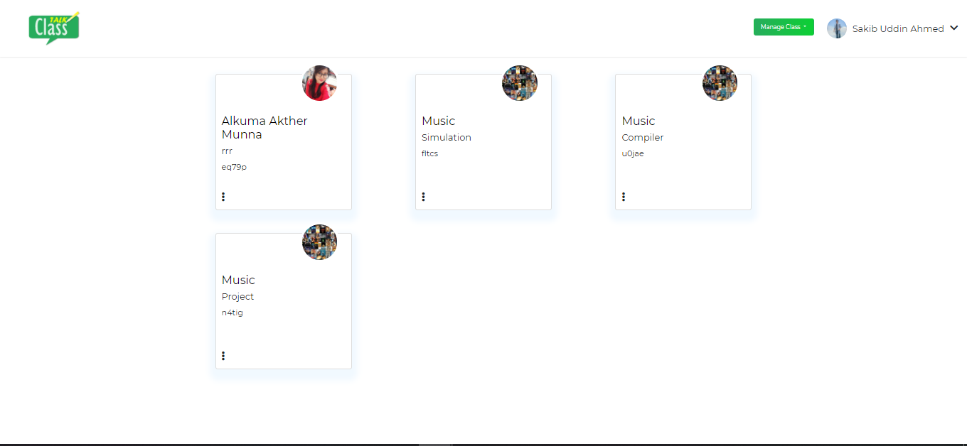

* + 1. **Stream Page of Class Talk**

The main page of our project where you can see posts assignments and can post any ideas and theories to this class users

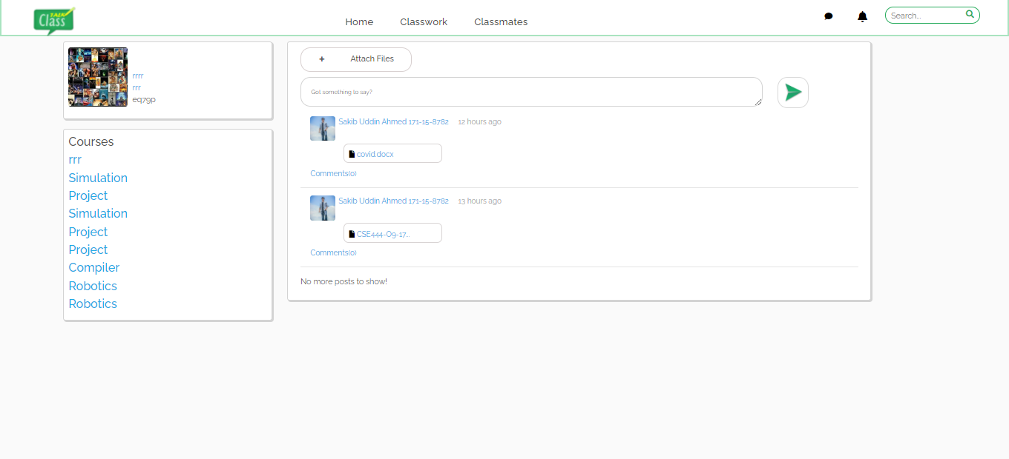

* + 1. **Classmate profile of class Talk**

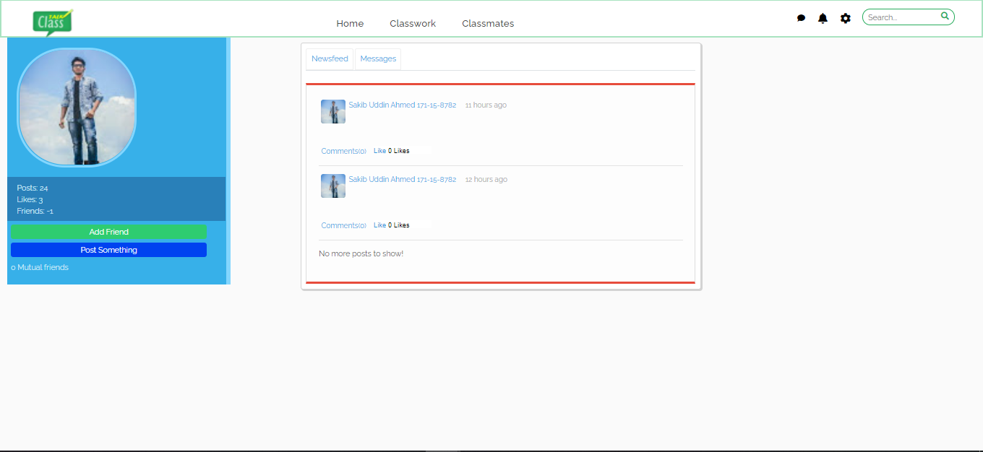

* + 1. **Assignment of classTalk**

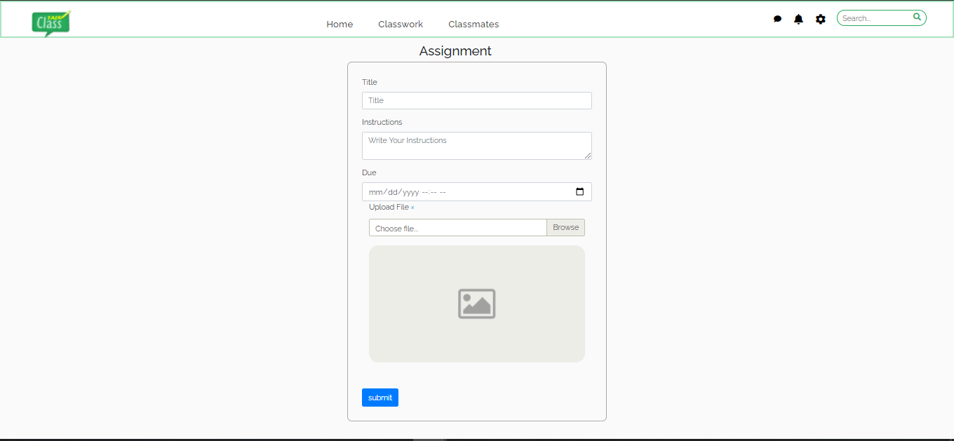

* + 1. **Group of classTalk**

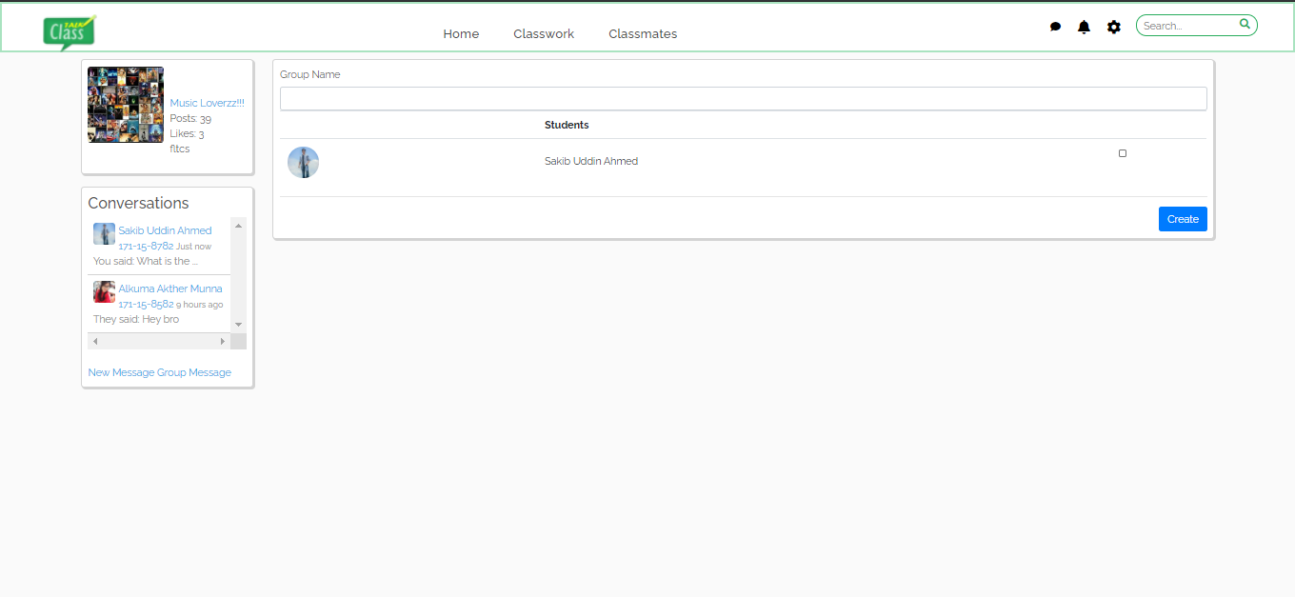

* + 1. **Massages of classTalk**

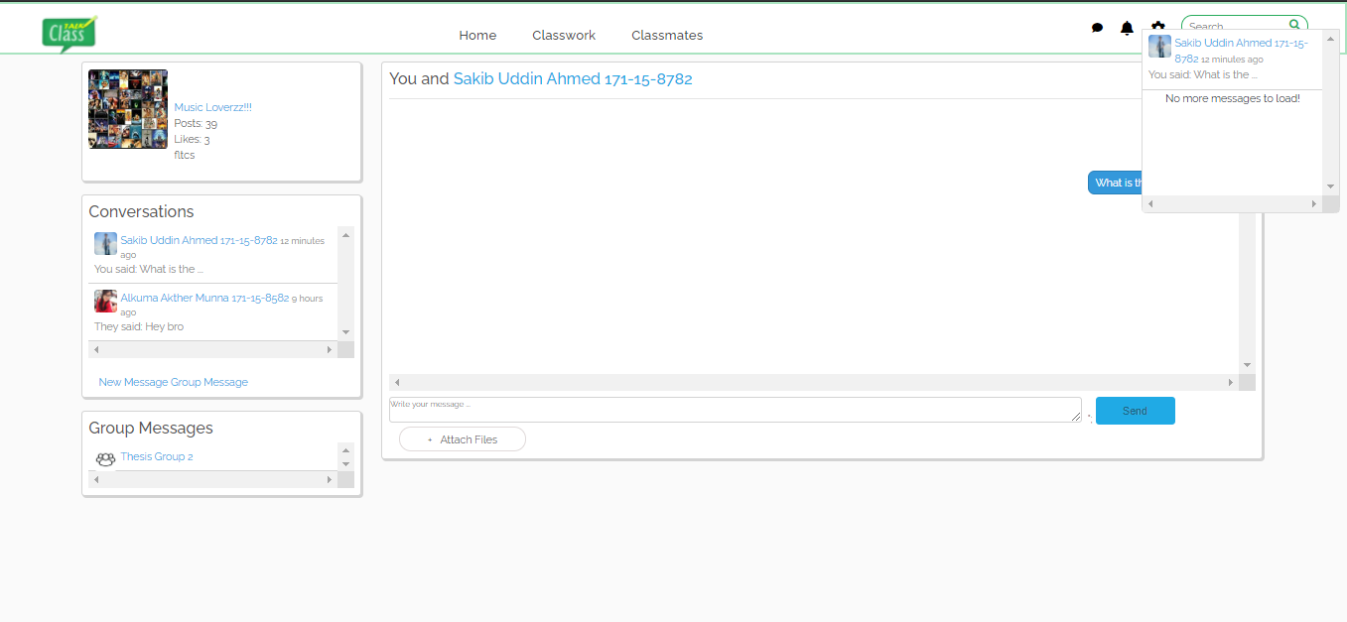

* + 1. **Class details of classTalk**

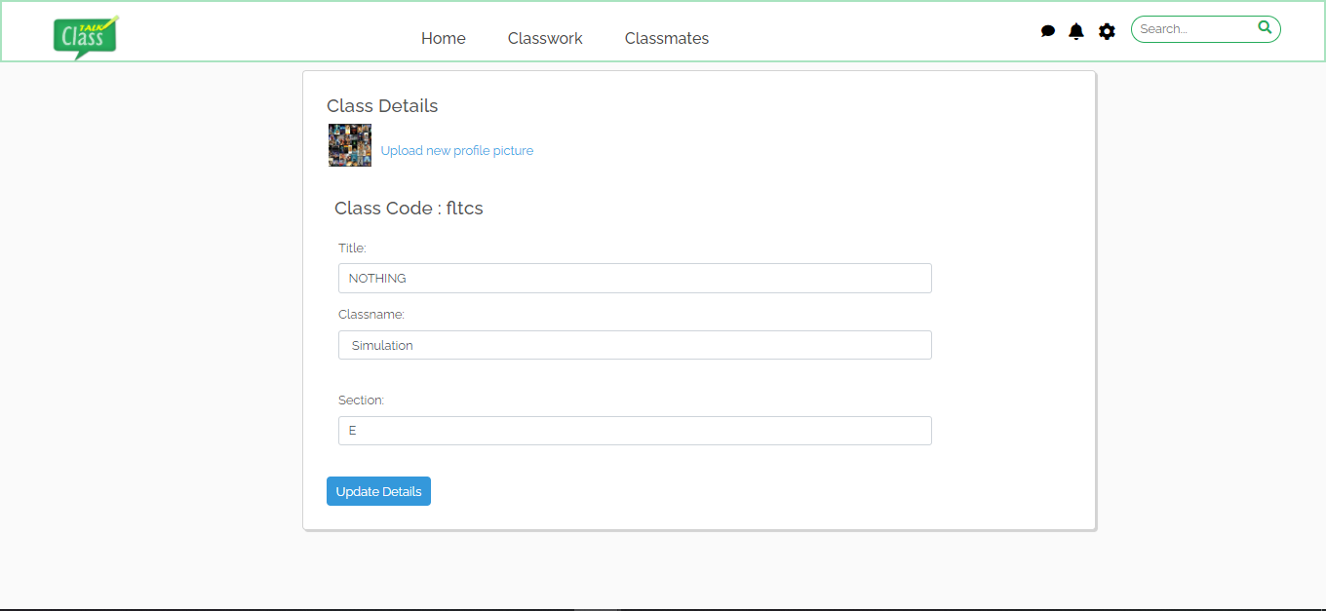

* + 1. **Grade Assignment of classTalk**

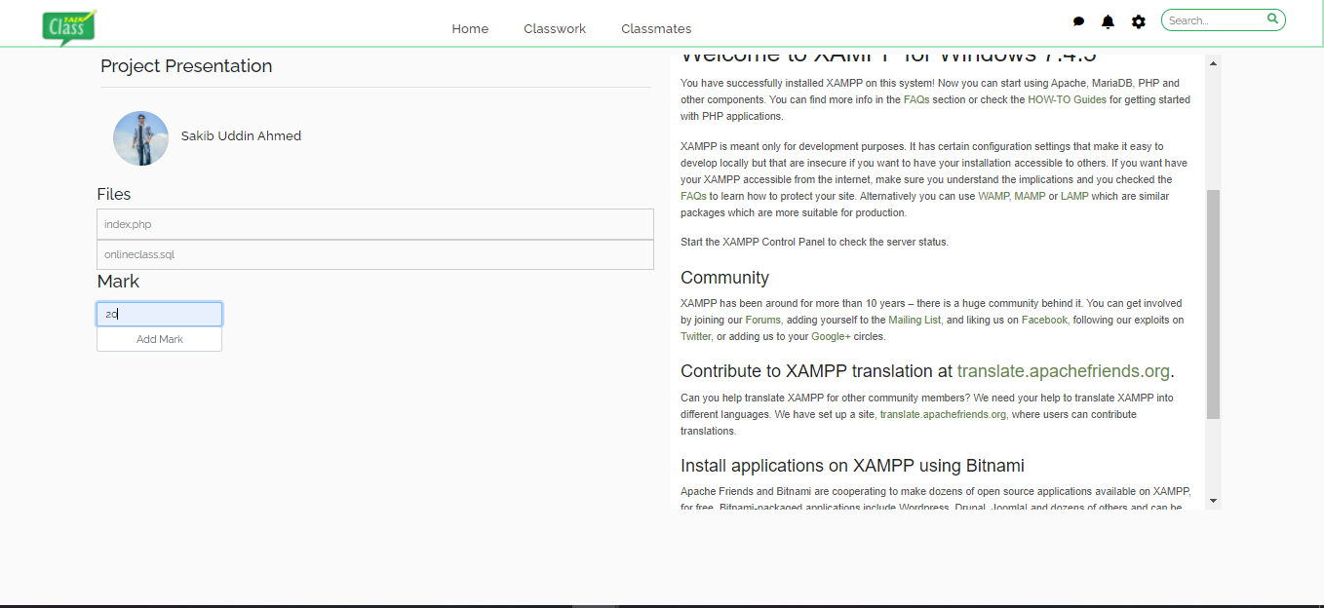

* 1. **Test Results and Report**

We tested our implemented code in google chrome browser.

**CHAPTER 6**

**Conclusion and Future Scope**

**6.1 Discussion and Conclusion**

This project is an exciting topic to work on. After going through the work, we faced many challenging tasks that are related to our educational system. We researched so many web applications that showed us the direction of how to develop our system.

We interact with the teacher and students about what type of problems they are facing. They were happy to know as it will save time and they will be able to attend an online class. They don’t need to meet their teachers physically.

Despite everything we achieved, we faced many challenges to finish this project. After all, it’s an online-based system. The opportunities provided through this web application is huge.

**6.2 Goal**

Our goal is to make a complete platform for our education system. Because in Bangladesh, most of the sectors are now much developed than this. Through our project users can save their valuable time. We are trying to make life easier with this section also.

**Goals of Implementation**

Follow the guiding principles established for the project.

• Maximize the opportunities and usage of the new system by search engine friendly scripts.

• Develop a comprehensive timeline, and develop workflow and decision making to ensure that milestone dates are met and the project is completed within the established timeline.

• Develop and follow a decision-making structure that will ensure that required decisions are made within the designated time frame in order to keep the project on time and on budget.

• Manage implementation costs to stay with the established project budget.

• Develop and follow strategies that will result in an orderly and then efficient transfer of system knowledge to users.

**6.3 Scope for Further Developments**

The current situation does not provide an internet registration system. The only service available on the internet is the organization of the schedule of the student for the incoming semester, without any sort of official version of the schedule. The student still must go to his advisor’s office, talk his schedule over with him, get it approved and signed, then take the approved schedule to the registrar’s office to be officially signed in.

The scope of this project is not much beneficial for a developer but it’s very beneficial for the new generation. Students nowadays showing interest in an easier life lead and want everything possible on the internet. From their perspective, we are building this project. Especially we include a chatting system and a counseling hour behind sharing a post. It helps students to develop their study. Whom are don’t feel free to communicate with teachers can easily solve their problem with a counseling hour through chat. It will create a huge space for students to share anytime with teachers by chatting. They can get their lectures online.

**REFERENCES**

1. W3School.com
2. google.com
3. <https://www.scribd.com/doc/59220739/SRS-documentation-of-Virtual-Classroom-System-SRS-documentation-of-Personal-Identity-Management-SRS-documentation-of-EMentoring-for-women-system>
4. <https://www.academia.edu/15823029/Software_Requirements_Specification_For_Online_Training_Application>
5. <https://web.wpi.edu/Pubs/E-project/Available/E-project-050118-070149/unrestricted/EduLinkUserGuide.pdf>
6. <https://ac.aup.edu/~croda/SampleStudentsWork/cs348/finalProjectS07/final%20presentation/final/Volere_Specifications_FV.pdf>
7. <https://www.researchgate.net/publication/289292796_A_web-based_virtual_classroom_system_model>
8. <http://www.fao.org/3/i2516e/i2516e.pdf>
9. *Kerr, Dara (May 6, 2014).*[*"Google unveils Classroom, a tool designed to help teachers"*](https://www.cnet.com/news/google-unveils-classroom-a-tool-designed-to-help-teachers/)*.*[*CNET*](https://en.wikipedia.org/wiki/CNET)*.*[*CBS Interactive*](https://en.wikipedia.org/wiki/CBS_Interactive)*. Retrieved April 28, 2017.*
10. <http://www.uft.org/linking-learning/pros-and-cons-google-classroom>
11. <https://edtechreview.in/trends-insights/trends/2902-10-exciting-new-google-classroom-features>
12. <https://en.wikipedia.org/wiki/Learning_management_system>
13. <http://blog.online.colostate.edu/blog/online-teaching/5-discussion-ground-rules-for-the-online-classroom/>

**APENDIX**

**Appendix A: Project Reflection**

If we can complete our project with all over our country then it will be a huge platform for our education system. It can be a startup business also. Our target is to work on it in future. Hope that it will help students a lot.

**Appendix B: Related Diagrams**

As there are no such work on our project but there is an app which is partially related to our work. Only some website is available on online classroom.